* 1. **Description of the service-oriented computing system that your team plans to develop:**

Our main services allow end-users to perform tasks on their documents (upload, download, encrypt, decrypt, filter word, and translate a word.) We will also provide our users with two elective services. One for the weather, and the other for the National Park Services.

* 1. **A diagram showing the overall system design:**

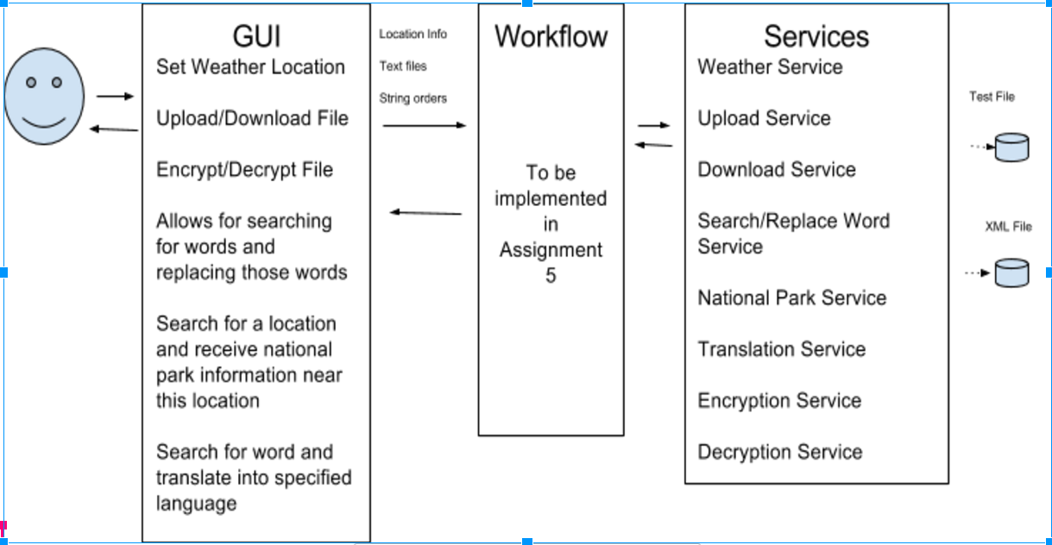

* 1. **service directory:**

|  |  |  |  |  |
| --- | --- | --- | --- | --- |
| **Service Directory:** The team plan to complete the following services.  **This page is deployed at:http://webstrar6.fulton.asu.edu/** | | | | |
| **Team name:** Ctrl-Z | | | | |
| **Provider name:** | **Service name,**  **with input and**  **output types** | **TryIt Page** | **Service description** | **Planned resources need to implement the service** |
| Amjad Alqahtani | Word Filter  Input: String  Output: String | http://webstrar6.fulton.asu.edu/page1/ | Word Filter Service: This Service will filter out the function words such as "a", "an", "is", ... as well as strings between two angle brackets "<" and ">" The method here takes a string as in input and returns a string. | Write my own code and use local component to implement the service. |
| News Service  Input: String  Output: String (URL) | http://webstrar6.fulton.asu.edu/page1/ | Returns a URL to a list of links about a specific topic | Google News URL + Own code |
| What are you hungry for?  Input: String- typeOfFood, string- zipcode  Output: Json object | http://webstrar6.fulton.asu.edu/page0/ | Provides the 3 nearest restaurants based on type food (ex: tacos, pizza, pita, ..) | Uses a Yelp API as well as my own code |
| Binding Energy Calculator  Input: Int A , Int Z  Output: double | http://webstrar6.fulton.asu.edu/page0/ | Provides the binding energy of an atomic nucleus from its number of protons and neutrons based on the Liquid drop model. | Write my own code and use local component to implement the service. |
| Jan Van Nimwegen | Encrypt/Decrypt  Input: String  Output: String | http://webstrar6.fulton.asu.edu/page8/ | Allows end user to download a document | Write my own code and use local component to implement the service |
| Quick Sort  Input: String  Output: String | http://webstrar6.fulton.asu.edu/page8/ | Sorts a list of characters | Write my own code and use local component to implement the service |
| Stemming  Input: String  Output: String | http://webstrar6.fulton.asu.edu/page6/ | Finds the stem of a word | Write my own code and use local component to implement the service |
| Number2Words  Input: int  Output: string | http://webstrar6.fulton.asu.edu/page6/ | Converts a number into a string of letters | Write my own code and use local component to implement the service |